Morals 1

Morals: There are different ways to learn them

Kush Patel

WRIT 120

Professor: Ryan.M

Due: December 5th 2019

Morals 2

Abstract/mind map

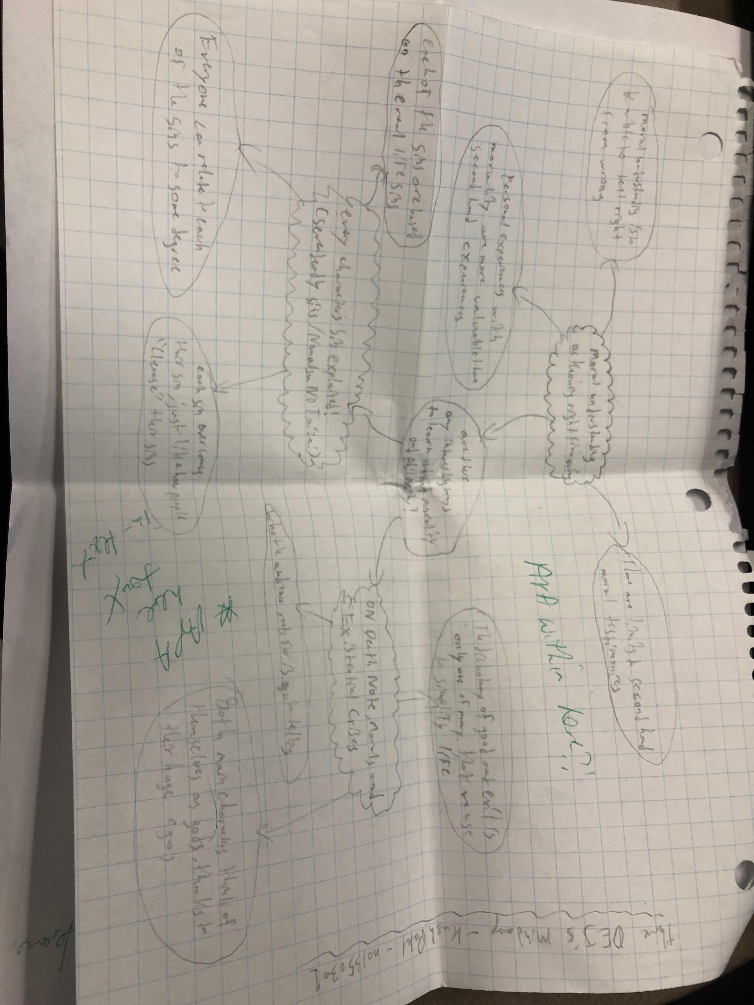

Morals 3

Philosophy and morals are best taught in a learning environment through a curriculum;

however, one can still get a good understanding of those topics without having to commit to a learning

environment. This strategy can be explored through many different media such as websites, movies, tv

shows, books etc. I'm going to be looking at what exactly morality is and which medias in particular can

provide a satisfactory understanding on this topic.

Before talking about how other medias can educate one on morality, we must first know what

morality is. Silwa’s “Moral Understanding as knowing right from wrong” goes over this matter by

providing the following information. To have an understanding in morality is to have a “valuable

epistemic and moral good” (Sliwa, P. 2017). This statement means that having the ability to know right

from wrong is looked as a strong attribute to have in oneself.

The argument being made in this academic journal is that moral understanding is “a matter of

knowing right from wrong” (Sliwa, P. 2017). It cannot be looked at too narrowly as Alison Hills – another

person who wrote an academic journal on this matter – does. Her argument does not take in the

“importance first-personal experience” (Sliwa, P. 2017) to acquire moral understanding. This source of

experience allows us to heighten our ability to hold more moral understanding within us.

To have a greater moral understanding capacity, we must acquire more firsthand experiences of

morality. This method allows us to give better moral reasoning capabilities and also let us arrive to our

own conclusions using our own words and thoughts. In short, moral understanding is an important

asset to anyone and having firsthand experiences with morality allows us to understand more.

The Seven Deadly Sins 4

Now onto one of the two medias I will be going over, that I believe can give a satisfactory

learning in morals and philosophy; The Seven Deadly Sins. The show itself is a great watch and

educational but for this paper I will be focusing on the analysis video by AnimeUproar “Every Characters

Sin Explained! (Seven Deadly Sins / Nanatsu No Taizai)”. The main cast is composed of seven individuals;

“Each sin got their sin given to them” (AnimeUproar, 2019) because of some sort of wrong they

had done. Their sins also happen to make up a chunk of their persona.

Throughout the course of the show, each character is shown to progress to a point where they

have overcome their sins and have changed themselves for the better. For example, the Lion Sin of Pride

Escanor is usually an arrogant and prideful person but when his friends needed him the most, he pleads

“And begs Mael to take the power back and save his friends. Thus, he overcomes the sin of pride by

prioritizing his friends above himself” (AnimeUproar, 2019). This showcase tells the audience that just

like how we as humans can cleanse our sins, they can too, in their own ways.

As the audience watches through the show, they sooner or later realize that they can relate to

every single one of the seven deadly sins in some sort of way or another. For example, in my case; I feel

like I can connect with the Boar Sin of Lust – Merlin. I used to be very obsessed with video games and

would often get carried away with them due to my love for playing them. The only difference is, their

sins define who they are as people whereas ours are apart of our individuality and often looked as by

others as no more than a bad habit.

Death Note 5

For the second – and final – media, I will be taking a look at Death Note. Specifically, an article

written by Zhang titled “On Death Note, Morals, and Existential Crises”. “Death Note’s protagonist Light

Yagami” (Zhang, L. 2016) is an athletic, smart, and kind person. He views the world as a “rotten place

full of despicable people” (Zhang, L. 2016). One day, ne notices a notebook falling from the sky. After

school he looks for it finds what’s called the Death Note. The way it works is that the person whose

name is written in the book will die in forty seconds as long as the user has the victims face in mind and

real name.

Light uses this notebook to kill “a criminal (a death row criminal at that)” (Zhang, L. 2016) to test

the legitimacy of the Death Note and to his surprise it kills the man. “L, an inhumanly intelligent

detective and prodigy, discovers the peculiar death trend of criminals dying from heart attacks and

tackles the case.” (Zhang, L. 2016). The rest of the show is about the two engaging a battle of wits, one

ideology versus another.

Light thinks that people that commit crime are what is wrong with this world and wants to

reborn the world by killing all criminals, while L believes that Light’s sense of justice is childish and

heavily flawed. Both characters have enormous and think of themselves as gods and refuse to give in to

the others philosophy. This leaves the audience to decide who they think the protagonist is and who

they would like to root for as the story continues.

In conclusion, philosophy and morals can be taught in other methods rather than having to take

part in a learning environment. These methods can include watching shows such as The Seven Deadly

Sins and Death Note, and even other shows that I did not cover in this paper. This way, people who find

learning about it in class boring, have a way to receive a satisfactory education on the matters.

Morals 6

References: APA

Sliwa, P. (2017). Moral Understanding as Knowing Right from Wrong. *Ethics*, 127(3), 521–552. doi: 10.1086/690011

AnimeUproar. (2019, April 5). *Every Character's Sin Explained! (Seven Deadly Sins / Nanatsu no Taizai)* [Video File]Retrieved October 6, 2019, from <https://www.youtube.com/watch?v=l1-vctXL-KU&t=411s>.

Zhang, L. (2016, November 15). On Death Note, Morals, and Existential Crises. Retrieved from <https://sites.duke.edu/anime/2016/11/15/on-death-note-morals-and-existential-crises/>.